

Farming With My Team
SESSION 6:
DEALING WITH CHALLENGES

“Inspiring People to improve through new knowledge and skills”

Copyright
The materials (“Materials”) contained in this publication are provided for education purposes only and for delivery by PD Training trainers.
The “Materials” are not and not intended to be advice. You should not act or refrain to act on the basis of any of the material in this publication without first satisfying yourself as to the truth or accuracy of all information given.
This manual is the intellectual property of PD Training and if you wish to copy, modify, distribute, adapt in any way then you must have written permission from PD Training.
PD Training will work in accordance with the Copyright Act 1968

Table of Contents
1
Session 6: Dealing with challenges 4
Welcome 4
Situational Leadership 5
Workplace Conflict 9
From Wince to Scream 10
How leaders can add to conflict 13
Having challenging conversations 18
The benefits of networks 21
Post Session Activities 22
Action Journal 22
Managing performance 22
Conflict Resolution 22
References 23

“The way to achieve your own success is to be willing to help somebody else get if first”
Lyanla Vanzant

Session 6: Dealing with challenges

Welcome
Welcome to Session 6 of Farming With My Team.
In this session we will explore the leader’s response to challenging situations. Firstly we will look at how a leader can be flexible to suit the conditions of a situation. We will then look at dealing with conflict in the workplace and how to have challenging or difficult conversations. Lastly we will look at how to make the most of the farming network that you belong to.

Situational Leadership
During the mid-1970s, Paul Hersey and Ken Blanchard developed a model of leadership. Their model looked at how the leader’s style could change depending on the needs of those being led. They argued that if you compare two constructs of task achievement, commitment and competence, there emerges four leadership styles. As the worker or follower moves through changes in these two constructs, so too should the style of the leader.
In the diagram below are mapped the two constructs. D1 to D4 refers to the development level of the worker.
Competence (X axis) : The demonstrated knowledge and skills the individual brings to a specific goal or task.
Commitment (Y Axis) : The individual motivation and confidence on that goal or task

D1 - Enthusiastic beginner
D2 - Disillusioned Learner
D3 - Competent but cautious
D4 - Self-Reliant Achiever
Commitment
High
High
Low
Time
Competence

If someone is introduced to a new task where they have yet to learn the skills, they will start off as an enthusiastic beginner. Initially they may struggle with the task and the acquisition of the news skills and knowledge. As their confidence picks up, so too will their competence and commitment.
The end goal is to move all workers to D4 or to be self-reliant

The Situational Leadership Model addresses four types of leadership styles based on the following:
- Telling/Directing
- Selling/Coaching
- Participating/Supporting
- Delegating
High

Commitment

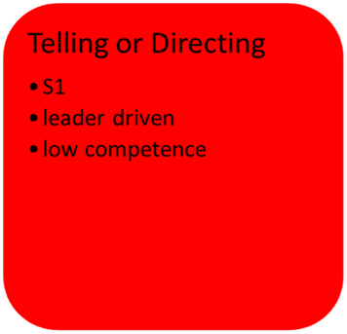
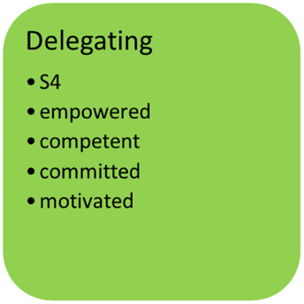
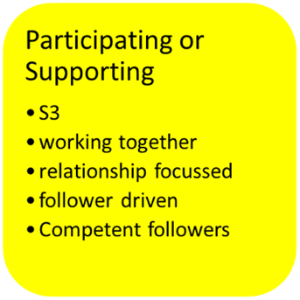
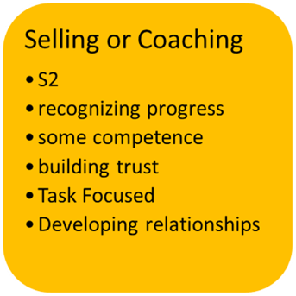
D3 - Competent but cautious – high competence, variable commitment
D4 - Self-Reliant Achiever – high competence, high commitment
D2 - Disillusioned Learner – some competence, low commitment
D1 - Enthusiastic beginner – low competence, high commitment
High
Competence
Low
Time
Leadership Styles
- S1 – High Directive – Low Supportive
- S2 – High Directive – High Supportive
- S3 – Low Directive – High Supportive
- S4 – Low Directive - Low Supportive

Activity: Leadership Styles Displayed
Watch the video and using the descriptions on the previous page determine which leadership style is being used and what tells you this.
Scene | Leadership Style being used and why?
1
2
3
4
5
6

Activity: Changing my style on farm
In what on-farm situations would you use a telling or directing style of leadership?

In what on-farm situations would you use a selling or coaching style of leadership?

In what on-farm situations would you use a participating or supporting style of leadership?

In what on-farm situations would you use a delegating style of leadership?

Workplace Conflict
For most people the word ‘conflict’ conjures up negative thoughts and brings to mind past experiences where they were on the losing end of something or suffered possibly physical and emotional distress as a result. But conflict is not all bad. If it wasn’t for conflict, we might still believe that the Earth was flat.
Activity: the good and the bad of conflict
How can conflict be seen as constructive in the workplace?

In what ways can it be seen as destructive?

From Wince to Scream
Most of us have probably witnessed or been directly involved in escalating tension and conflict in the workplace.
(Source: adapted from © The Conflict Resolution Network PO Box 1016 Chatswood NSW 2057 Australia)
When should leaders intervene and how?

Activity: What causes conflict on farm
Consider your farm.
List the sources of (what gives rise to…) relationship conflict.

List the sources of (what gives rise to…) task conflict.

What are the common elements of both categories of conflict?

Psychologists Art Bell and Brett Hart suggested eight common causes of conflict (Mintz 2011):

How leaders can add to conflict
Reflecting on Bell and Hart’s drivers of conflict, it becomes apparent that leaders can often contribute to conflict within their teams. You can play a part in recognising some of the pitfalls that beset teams and working positively to avoid them.

Micromanagement
What do we mean by micro managing?
A management style whereby a manager closely observes and/or controls and/or reminds the work of his/her subordinates or employees. This means that the employee has little room for freedom or input and feels the pressure of being constantly under scrutiny.
How can micromanaging contribute to conflict?

What can you do if someone has told you that you micromanage?

Poor Understanding
How can poor understanding contribute to conflict?

Scenario 1: It will take care of itself.
Maria has approached her farm leader claiming that a fellow team member, Jane, is bullying her. The farm leader says that Maria is overreacting and that Jane is just going through a rough patch and in a week or two everything will have calmed down. The farm leader is also reluctant to talk to Jane as when he last raised this ‘bullying’ issue with her she threatened to sue him for defamation.
How should the farm leader respond?

Scenario 2: What would you know?
Roxanne offered to assist her boss with the budget that her boss was struggling with. Her boss said, “You don’t have the experience for this and I really need to get this done. Also I need you to stick to what you were employed to do.” One week later Roxanne resigned.

Being divisive
Being divisive is playing favourites with your workers which creates divisions between them and gives rise to conflict. This perception amongst workers is due to a lack of transparency or equity about how work tasks are allocated or how relationships operate. Examples of divisive behaviour include:
- Excluding some people from conversations
- Excluding some people from decision making or discounting their input
- Picking the same people to assign new tasks to
- Picking the same people to assign more interesting work to
How can you ensure you are not creating divisions amongst your farm workers?

Vague Expectations
Clarity is essential to promote understanding and to guide businesses in achieving their objectives. The vaguer the task, instruction or objective the more issues and conflict will arise.

Activity: Clarity
How and why did conflict arise in the following scenarios?
Scenario 1
Manager: “Where’s that report I was after?”
Doug: “What report?”
Manager: “The one for the ABC Project.”
Doug: “I haven’t started it.”
Manager: “But I need it today and I thought the urgency in my voice when I asked you for it would have told you that.”

Scenario 2
Petra: “Miguel, I need you to ring Exon Engineering and tell them we need that part by Monday.”
Miguel: “But they don’t have it in stock and need to order it in and when I ordered it, you said there was no urgency”
Petra: “I’ve changed my mind, it’s that simple, and we are the customer.”
Miguel: “Won’t they get mad at us? “
Petra: “I am sure you can handle it.”

Setting Poor Standards.
You may have heard of the expression – ‘What you allow, you teach’. The standard of behaviour that persists in a workplace is dependent on what messages are sent on what is acceptable behaviour. These messages are sent by everyone in the workplace but they are endorsed by the leadership.

Activity: Case Study
Sally arrived at her new farm-hand job early on her first day. Sally considered herself a hard worker and had excellent references from her last job. Bill, her team leader, was not at work. Another farm-hand showed Sally around and helped her settle in. She gave Sally an ‘induction’ kit for new starters and apologised that it was out of date and said not to read it too closely as no one followed the information it contained.
Bill eventually arrived. He didn’t explain to sally why he was late or mention anything about it. Bill motioned Sally into his office. “Listen,” he said “We run several farms in the area. When the big boss isn’t here we all take things a little easy, because that keeps everyone happy. If the big boss visits, you need to be on your toes and you need to look busy. If you remember to do that then you will last longer than the last person we employed.”
What messages are being conveyed by Bill?

What are the potential source of conflict being fuelled by Bill and the workplace culture?

Having challenging conversations
Leadership and management is dotted with challenging conversations – conversations that deal with
- performance matters
- difficult topics
- conflicting opinions
- uncertainty
- discomfort
Avoiding challenging conversations will usually make matters worse because it could lead to:
- Lower morale amongst workers
- Reduced levels of trust
- Prolonging or worsening the issue
- Reduced levels of productivity and engagement
- Higher levels of absenteeism
There are two key considerations when approaching challenging conversations:

Entering a difficult conversation is something that we do for several reasons, but the biggest one is that we are responsible for creating productive workplaces. Positive intent includes the idea that you have good reason for what you are saying and doing, and so do other people. It’s best to come from a place of concern and providing support when you have these difficult conversations, and positive intent helps to do that. It demonstrates your belief that the other person is not being defiant – unless that later proves to be the case – and that you want to help them do better. In order to demonstrate your positive intent, avoid making negative assumptions and statements, and focus on the future instead of the past.
Establishing positive intent

Deciding if a behaviour is a problem - Another aspect of positive intent is to accept that not everyone is like you. People have strengths, and they also have limitations. You have to consider why a particular behaviour is a problem. Is it a problem for you because of your perspective, or is it genuinely a problem?
Deciding if a behaviour is a problem

Activity: Conversations I find challenging
What types of conversations do you find challenging on farm?

What makes these conversations challenging for you?

Steps for conducting a challenging conversation
If you decide to go ahead with a conversation work through the following steps:

The benefits of networks
One of the insights you would have gained from this program is that the challenges you face on farm are not peculiar to you; they are common to many farm leaders. Networking is a way of tapping into the collective wisdom of farm leaders to assist you in dealing with such challenges and for you to provide guidance to others who are facing their own challenges.
What networking opportunities have you taken advantage of?

What else could you do to get more involved in the dairy industry, particularly in networking?

How can you take advantage of the farming network that has been formed as part of attending this leadership course?

Post Session Activities

Action Journal
Your Action Journal is a chronological personal record of your reflections as you move through this course and what actions you will commit to, to improve as a leader. A Journal is another mode of self-reflection and is a vehicle to promote self-awareness and self-improvement.
At the end of each session you will be encouraged to reflect on what was covered and decide what actions you will take to lead more effectively.

Managing performance
Use the self-reflection activity to review how you currently manage performance on-farm.

Conflict Resolution
Have a discussion with a colleague on how you have managed or plan to manage conflict on-farm. How have you planned for this, what actions did you take and what was the outcome. What would you do differently next time?

References
Bell A 2002, Six Ways to Resolve Workplace Conflicts, < http://www.usfca.edu/fac-staff/bell/article15.html >
Hart B 2000, Conflict in the workplace, < http://www.excelatlife.com/articles/conflict_at_work.htm >
Mintz S 2011, Dealing with conflict in the workplace < http://www.workplaceethicsadvice.com/2011/10/dealing-with-conflict-in-the-workplace-1.html > viewed June 2017
Riaz M K and Junaid F 2013, ‘Workplace Conflict: constructive or destructive’, SSRN Electronic Journal, April 2013 < https://www.researchgate.net/publication/254968171_Workplace_Conflict_Constructive_or_Destructive > viewed June 2017

