

Farming With My Team
SESSION 5:
THE IMPORTANCE OF FEEDBACK

“Inspiring People to improve through new knowledge and skills”

Copyright
The materials (“Materials”) contained in this publication are provided for education purposes only and for delivery by PD Training trainers.
The “Materials” are not and not intended to be advice. You should not act or refrain to act on the basis of any of the material in this publication without first satisfying yourself as to the truth or accuracy of all information given.
This manual is the intellectual property of PD Training and if you wish to copy, modify, distribute, adapt in any way then you must have written permission from PD Training.
PD Training will work in accordance with the Copyright Act 1968

Table of Contents
1
Session 5: The importance of feedback 4
Welcome 4
Why feedback matters 5
When to give feedback 6
Types of feedback 7
Giving feedback 8
Feedback Framing Tool 9
Tips on Giving Feedback 10
Seeking Feedback 14
The Power of gratitude 15
Post Session Activities 16
Action Journal 16
Practice giving feedback to others 16
References 17

“The way to achieve your own success is to be willing to help somebody else get if first”
Lyanla Vanzant

Session 5: The importance of feedback

Welcome
Welcome to Session 5 of Farming With My Team.
In this session we will explore the importance of feedback – its link to performance and how best to both deliver and receive feedback.
Feedback is essential for the practice of leadership for two main reasons:
Firstly, it is the leader’s role to tell the people they lead how they are doing, how they are performing. Every worker desires to feel good about what they do, to feel that their contribution is worthy, and to understand when their efforts miss the mark and why – leaders help provide that input.
Secondly, leaders by their very nature need to understand if they are effective, if their workers are sufficiently motivated to perform to the level required. In this respect leaders are asking the question of others ‘How am I doing as a leader?’
A survey of 200,00 employees (Tinypulse 2014) showed the following as the key motivators for staff.
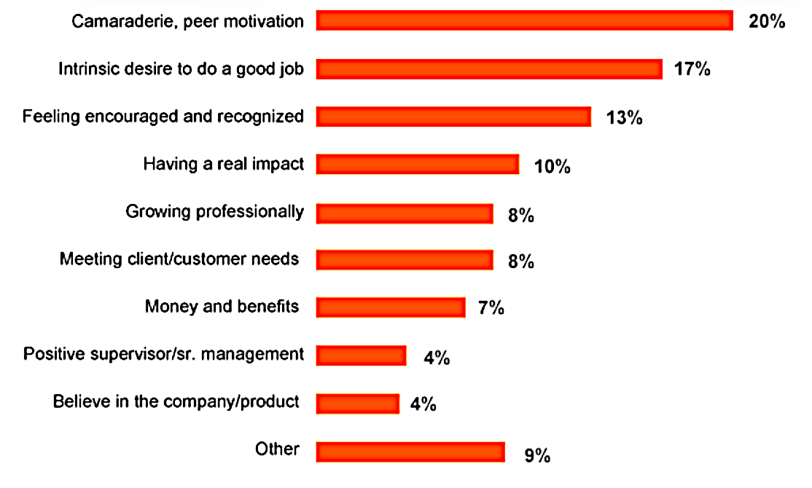
Three out of the top four motivators involves doing a good job, feeling encouraged and recognised and having a real impact. On the flip side, two of the main reasons for demotivating employees is insufficient information / communication from leaders and a lack of demonstrable action with people that are poor performers. Common to all of these points is the notion of feedback – providing information about a person’s performance.

Why feedback matters
As the survey on the previous page showed, we are motivated by the fact that what we do matters. We may come to this notion independently of others however this may provide a jaundiced view divorced from reality. The better way of understanding how we are doing is by seeking feedback directly from those who can attest to what we do. As leaders we have a choice in how we manage feedback on-farm, whether we are in the habit of only giving feedback in response to an event or whether we make feedback a habit in itself.

Activity: My feedback experience
Describe an example of effective feedback you received and why this was so:

Describe an example of ineffective feedback you received and why this was so:

How often would you give feedback to your farm workers

What do you give feedback on?

Are you more inclined to give feedback proactively or reactively? Why?

When to give feedback
Feedback can take place:
- In the moment – as a direct response to an action
- At an appropriate time very soon after an action
- As part of a formal review cycle process for an individual or team
The important thing to note about timing is that the longer the interval is between an action and feedback, the more difficult it is for the person receiving the feedback to recall details of the action, and, the less impact the feedback will have, begging the question ‘Why didn’t you tell me sooner?’
When do you normally give feedback after an event or action?

Activity: Why we don’t give feedback
If feedback matters why are we sometimes reluctant to give it or ask for it?
Discuss reasons why we may be reluctant to give feedback on-farm.

Discus reasons why we may be reluctant to receive or ask for feedback.

Types of feedback
There are two types of feedback that we give and receive:

Activity: Examples of supportive and corrective feedback
What are some examples of supportive and corrective feedback that you have delivered on-farm?

Giving feedback
Balanced feedback involves commending things done well as well as identifying and recommending changes while ensuring that important feedback messages are understood and acted on. Balanced feedback stops people feeling de-motivated by the feedback they may find challenging. It is especially important to provide balanced feedback during performance reviews and assessments because those discussions relate to a stretch of time and not an isolated issue or incident.
Commend | “I appreciate the time you spent on…”  “In general, I am happy with your performance. I have been impressed with the way you have…”
Recommend | “One area where I’d like to see an improvement is…”  “Perhaps next time around you could also…”  “It’s not yet meeting my expectations. What I’d like to see is…”  “One way of developing your skills even further would be to…”
Commend | “I feel confident that once you implement the strategy/is that we have been working on, it will go better next time.”  “I appreciate your willingness to take on board feedback.”

Example:
“Susan, well done in bringing the cows over today and setting them up on the milking machine. I was noticing that you had some trouble disinfecting the teats and not following the SOP for this. You pick things up pretty quickly so lets chat if there is something you are unsure of in the SOP.”

Feedback Framing Tool
The SSI model can be used to prepare for giving feedback - both supportive and corrective.
Here are two examples:
Damien was late getting to work this morning and didn’t alert anyone. He was meant to come in early to help with some equipment maintenance that needs two people to complete the task. This meant that the maintenance schedule has fallen behind.
Damien’s farm manager is having a feedback session with Damien:
“Damien…”
Situation: “This morning you were late for work and didn’t notify anyone that you would be late.”
Standard: “If you are going to be late especially for maintenance critical work, you must let Colin know so that we can try and compensate.”
Impact: “This means we now have to put off that maintenance till next week as Mick is away for next few days.”

Sally worked two days last week on another farm to help out as they were short staffed. The farm manager rang to say how pleased she was with Sally’s work and how knowledgeable she is.
“Sally…”
Situation: “I had a call from Molly Preston yesterday, She rang me to say how pleased she was that you could help out last week”
Standard: “You went out of your way to help, staying back quite late one evening and passing on your knowledge to their new farm hand”
Impact: “This means that they now have a much better idea on how to maintain their new irrigator. Well done.”

Tips on Giving Feedback
The following tips on giving feedback are courtesy of and adapted from the ACT Government (ACTPS n.d.) and are for structured feedback sessions that may be supportive and more likely corrective.
Tip #1 Choose an appropriate time and place
- Give feedback as soon as practicable (within 24 hours of a specific event or instance if you can).
- Consider your schedules – make sure you and the other person are both free for the discussion
- Choose a meeting venue that is private
- Allow enough time so that you are not rushed.
- Never give corrective feedback in public.
- Make sure you are in right frame of mind to provide the feedback. If not delay it but not for too long

Tip # 2 Give feedback in person whenever you can
- Face-to-face feedback conversations are the best way of giving feedback. If you supervise a remote team and are unable to be there in person consider skype or some other technology that allows both parties to view each other.
- If a phone connection is the only option be conscious of the need to ask more questions and prompt the person more often and double check for understanding at each point in the conversation. At the end get the person to repeat back to you what has been agreed
- Be aware of your/their body language. Smile when it’s appropriate and listen by turning your body toward the other person and nodding to show when you understand their words.

Tip # 3 Be Prepared
- Ask yourself what you want to achieve from the discussion? Is it supportive or corrective feedback you wish to give?
- Plan what you want to talk about and what you will say:
  - be specific and use examples
  - develop questions to seek the other person’s views and ideas and encourage a two-way discussion
    - e.g. how do you think it went?
    - what could we have done differently?
  - if you are seeking change or improvement clarify exactly what you want.
NB: when planning your discussion; it might help to write your plan down. You can take it into the meeting with you and use it to help you keep the discussion on track.
- Have an open-mind. You should be prepared for new information to come to your attention as you discuss your feedback with the other person. If there is new information that needs to be verified make a note and state that this will need to be done
- If the feedback is about correcting behaviour the following may help you to get ‘the right words’ clear in your mind prior to the discussion or ‘pin down’ exactly what you want to see changed:
  - the values of the organisation
  - any code of behavior or code of conduct or other document which specifies expected behaviours
Tip # 4 During a Feedback Session
- First, confirm with the other person that it is a suitable time and place.
- Break the ice by briefly mentioning something that is of interest to the person but not related to the feedback you are giving
- Begin the conversation by outlining the background/situation/issue and say what you’d like to get from the discussion.
- Important - the other person does the bulk of the talking – prompt where appropriate.
- Listen attentively and make a note of any point you would like to clarify.
- Encourage the discussion so that all points and example you wished to be covered are indeed covered
- If it is corrective feedback keep the description and conversation focussed on the behaviour and not the individual
- Decide together what action you both will take after the meeting.
- Take time out: If the conversation begins to get emotional or you/they need time to ‘digest’ what is being said - arrange a break and reschedule the meeting for a later time.
- Check that the other person has understood what you have said.
- Thank the other person and state that you will confirm your conversation in writing
Tip # 5 Following the Discussion
- Record your discussion (including any action either of you have committed to) in an email to the other person
- Remember that the other person may need a little time to reflect on what was said in your feedback discussion - they may come to you later with questions or comments.
- Make sure to follow up on any action that was agreed

Activity: Practice Giving Feedback
In groups of three, practice giving feedback twice – one that is supportive and one that is corrective. You may use your own example or the examples below.
One person is to play the farm leader, another the farm hand with the third person observing.
Use the SSI model to plan your feedback session which should take a maximum of three minutes for each of the two sessions for each person. A planning page is overleaf.
Record any feedback below.
You should be able to think of a supportive example without too much trouble. Possible scenarios for corrective feedback:
- Not recording information accurately for newborn calves
- Rolling a quad bike and not reporting it
- Gossiping about another worker

Record any feedback from your observer here:

Feedback Planning Sheet
Supportive Feedback
Situation

Standard

Impact

Corrective Feedback
Situation

Standard

Impact

Prompts for Observer
- Confirmed was still OK to go ahead with meeting
- Broke the ice to put the person at ease
- Outlined the issued according to SSI
- Let team member do most of the talking
- Kept the conversation going
- Agreed the next steps after the meeting
- Agreed to follow up in writing

Seeking Feedback
Asking for feedback is one of the best ways to feel ‘in control’ of your work, get an accurate idea of what is expected of you and judge how you can improve even further.
Example questions for seeking feedback:
During a performance discussion | As part of everyday work
How can I better support you to do your job? | How could I have supported you better on this task?
What could I do differently that would help you do your job? | Have I given you enough information and guidance?
What am I doing that helps you do your job? | Is there anything more I can/could have done when you were working on this?
Am I giving you enough feedback? | What would you like me to do differently next time?
Do you feel you have been given opportunities to use and develop your knowledge and skills? | Were you happy with the level of autonomy/responsibility you were given?
Am I doing anything that hinders your capacity to do your job? | Could I have provided you with more feedback along the way?

Reflecting on feedback
When you seek or receive feedback you need to think carefully and objectively about what the feedback means.

The Power of gratitude
A survey of 1700 workers found that those workers who felt valued at work were much more likely to feel motivated and to stay on.

The survey firstly separated workers into those that felt valued and those that didn’t then asked them the same questions. 93% of those workers who felt valued were motivated to do the very best for the employer compared to only 33% of those who didn’t feel valued.
What this means is that the simple act of showing gratitude to your workers can make a big difference in attitude and behaviour amongst workers.
Activity: How I show gratitude
What do you do on farm to show gratitude towards your dairy workers?

Post Session Activities

Action Journal
Your Action Journal is a chronological personal record of your reflections as you move through this course and what actions you will commit to, to improve as a leader. A Journal is another mode of self-reflection and is a vehicle to promote self-awareness and self-improvement.
At the end of each session you will be encouraged to reflect on what was covered and decide what actions you will take to lead more effectively.

Practice giving feedback to others
Before the next session find one or more opportunities to give supportive and/or corrective feedback to staff and practice using the feedback sandwich and the SSI model.

References
ACTPS n.d., The Art of Feedback: Giving, Seeking and Receiving Feedback, < http://www.cmd.act.gov.au/__data/assets/pdf_file/0003/463728/art_feedback.pdf > viewed October 2016
American Psychological Association 2012, Workplace Survey, < http://www.apa.org/news/press/releases/phwa/workplace-survey.pdf > viewed February 2018
Tinypulse 2014, The 7 key trends impacting today’s workplace, < https://www.tinypulse.com/2014-employee-engagement-organizational-culture-report > viewed October 2016

