

Farming With My Team
SESSION 2:
WHAT MAKES ME A LEADER

“Inspiring People to improve through new knowledge and skills”

Copyright
The materials (“Materials”) contained in this publication are provided for education purposes only and for delivery by PD Training trainers.
The “Materials” are not and not intended to be advice. You should not act or refrain to act on the basis of any of the material in this publication without first satisfying yourself as to the truth or accuracy of all information given.
This manual is the intellectual property of PD Training and if you wish to copy, modify, distribute, adapt in any way then you must have written permission from PD Training.
PD Training will work in accordance with the Copyright Act 1968

Table of Contents
1
Session 2: What makes me a leader 4
Welcome 4
Personal Values and Personal Style 4
Diversity and Workplace Culture 6
REACH Profile Review 8
Personal Style Markers 10
Leading Dimensions 13
Recognising your Strengths 15
Post Session Activities 21
Action Journal 21
The cultural health of my farm 21
References 22

“The way to achieve your own success is to be willing to help somebody else get if first”
Lyanla Vanzant

Session 2: What makes me a leader

Welcome
Welcome to Session 2 of Farming With My Team.
In this session we will explore the mix of skills required by effective leaders and gain a better understanding of how you as a leader are responsible for shaping the culture on-farm.

Personal Values and Personal Style
Values are the things that we hold dear, things that guide how we make decisions and live our lives. They give our lives purpose. They tell us what we should attach importance and priority to. Values inform what our principles and morals are, and, they are the things we cling to when we are tested.
Values are also important because they guide how we manage and lead. They become evident to others through our behaviours – what we say and how we act. They become the cornerstones of workplace culture – the behaviours that are acceptable in a workplace.
In corporate environments, the values of an organisation are often arrived at through the collective input of a cross-section of workers. These values become enshrined in what the organisation stands for and end up attached to vision and mission statements and can be found in prominent places such as corporate websites, strategic plans and annual reports – to name a few.
But what about on the farm? In many cases, the values that drive behaviour on-farm are personal values held by a farmer, or farm manager or farming families. If it is important for organisations to state what their values are (what they stand for) and have all their employees sign up to, then it is equally important for farms and farmers to state their values so that farm workers know what they are and where they stand in relation to them.
Personal style is a reflection of your personality. It refers to the mix of preferences that people have in how they behave in common circumstances. Later in this session we will look at two dimensions of personal style – achieving goals and relating to others. Your values are expressed through your personal style.

Activity: What I value
On the next page is a list of values. Go through the list and circle the values that are important to you. Then review the list of the values you circled and place a tick next to those values that are the most important. Try and come up with a list of 10 values or less – these will be your core values.

Values list:
Accountability  Accuracy  Achievement  Adventurousness  Altruism  Ambition  Assertiveness  Balance  Being the best  Belonging  Boldness  Calmness  Carefulness  Challenge  Cheerfulness  Clear-mindedness  Commitment  Community  Compassion  Competitiveness  Consistency  Contentment  Continuous Improvement  Contribution  Control  Cooperation  Correctness  Courtesy  Creativity  Curiosity  Decisiveness  Democraticness  Dependability  Determination  Devoutness  Diligence | Discipline  Discretion  Diversity  Dynamism  Economy  Effectiveness  Efficiency  Elegance  Empathy  Enjoyment  Enthusiasm  Equality Excellence  Excitement  Expertise  Exploration  Expressiveness  Fairness  Faith  Family-orientedness  Fidelity  Fitness  Fluency  Focus  Freedom  Fun  Generosity  Goodness  Grace  Growth  Happiness  Hard Work  Health  Helping Society  Holiness  Honesty | Honour  Humility  Independence  Ingenuity  Inner Harmony  Inquisitiveness  Insightfulness  Intelligence  Intellectual Status  Intuition  Joy  Justice  Leadership  Legacy  Love  Loyalty  Making a difference  Mastery  Merit  Obedience  Openness  Order  Originality  Patriotism Perfection  Piety  Positivity  Practicality  Preparedness  Professionalism  Prudence  Quality-orientation  Reliability  Resourcefulness  Restraint  Results-oriented | Rigor  Security  Self-actualization  Self-control  Selflessness  Self-reliance  Sensitivity  Serenity  Service  Shrewdness  Simplicity  Soundness  Speed  Spontaneity  Stability  Strategic  Strength  Structure  Success  Support  Teamwork  Temperance  Thankfulness  Thoroughness  Thoughtfulness  Timeliness  Tolerance  Traditionalism  Trustworthiness  Truth-seeking  Understanding  Uniqueness  Unity  Usefulness
(Source: https://www.mindtools.com/pages/article/newTED_85.htm)

Diversity and Workplace Culture
In this session we have focused on you as a leader and what it is about your own unique characteristics that shapes how you think and act and therefore how you lead. We have also alluded to workplace culture and the values that define how things are ’done around here’.
The draft Australian Dairy Plan (ADP) talks of a ‘positive industry culture and narrative’ as key to transforming the Australian dairy industry. In particular the ADP states that:
- Leaders must role model the culture they want to see
- Leaders will need to communicate a narrative that reflects the values and beliefs of the desired culture
- A critical role for formal and informal leaders is to agree and communicate common behaviours and values
The sustainability goals and targets include (among others):
- Increasing the resilience and prosperity of dairy communities
- Providing a safe work environment for all diary workers
- Providing a productive and rewarding environment for all dairy workers
One of the key attributes of effective leadership is leadership that taps into the diversity that exists amongst dairy workers. This may include diversity of:
- Perspectives – people that view challenges and issues in different ways can only strengthen the final solution and provide more options
- Thought – people can contribute different thoughts on the same topic or issue which can lead to positive change and to innovation
- Lifestyle – some workers may work more positively if their lifestyle differences can be accommodated – within the parameters of working in the dairy industry
- Life experience – everyone has a different life experience and has met and dealt with numerous challenges. Their wisdom can be passed onto others to drive resilience and to drive innovation

Activity: Starting a conversation about workplace culture
What can I do on-farm to drive a conversation about workplace culture?

Activity: Strengthening diversity on-farm
What can I do on-farm to tap into the diversity that exists amongst my dairy workers?

REACH Profile Review
The REACH Personal Style Profile provides a description of the most common ways that people tend to achieve goals and relate to others in common circumstances
As we approach tasks and goals, and as we work with and around others, we tend to adhere to a style. While we don’t always follow the same routine, the way we approach tasks and relationships does tend to reveal a consistent pattern. We summarise this pattern using two specific sources of motivational drive:
Achievement Drive: this describes the way we approach tasks, processes and goals (the “what” of leading). At opposite ends of the Achievement Drive continuum are two approaches:
Thinking Orientated or methodical (a more tactical orientation to leading) and Action Orientated or urgent (a more strategic orientation to leading).
Relational Drive: this describes the way we engage emotionally with others (the “how” of leading). At opposite ends of the Relational Drive continuum are two approaches: Task Focused or guarded (a more enforcing orientation to leading) and People Focused or expressive (a more enabling orientation to leading).
These two sources of motivational drive interact to reveal one of four unique profiles which describe your primary leading style:
Counselor (the combination of Thinking Orientated Achievement Drive and People Focused Relational Drive)
Coach (the combination of Action Orientated Achievement Drive and People Focused Relational Drive)
Driver (the combination of Action Orientated Achievement Drive and Task Focused Relational Drive)
Advisor (the combination of Thinking Orientated Achievement Drive and Task Focused Relational Drive)
Your style influences how you define and carry out your leadership role. A practical way to describe this influence is by measuring two sets of leadership orientations that describe the “what” and the “how” of your leadership approach
Your responses will position your profile on a 2X2 grid based on the degree that you are thinking as opposed to acting oriented and people as opposed to task focused.
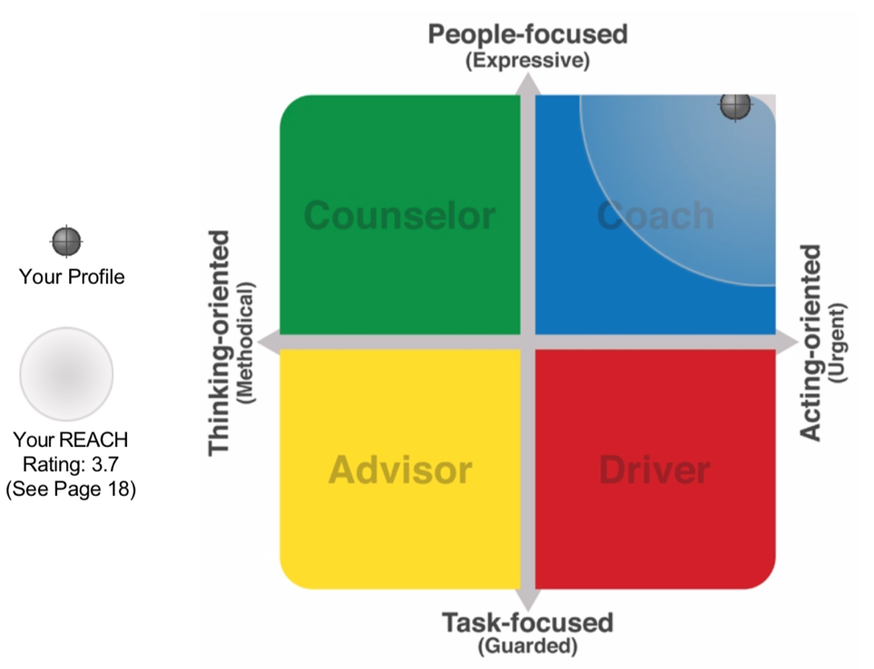

The agility of your unique profile is graphically displayed as a circular zone around your plot. This zone may be seen as the area of the matrix within which you feel most comfortable interacting with others. The larger the “REACH”, the greater the agility with which you may adapt to other profiles of influence when Relating to people and Achieving goals.
It is important to remember that all personality styles have merit and that each individual is a combination of different styles. Similarly, individuals will have different strengths. The REACH tool assists individuals in identifying the dimensions of their personality, where their corresponding strengths lie and where these strengths may hinder performance in some situations.

Personal Style Markers
While specific behaviours may vary based on the circumstances (such as at work or at home), an individual’s personal style will most likely be conveyed in a consistent manner. The following summary reveals how each of the four profiles may be most commonly recognised:
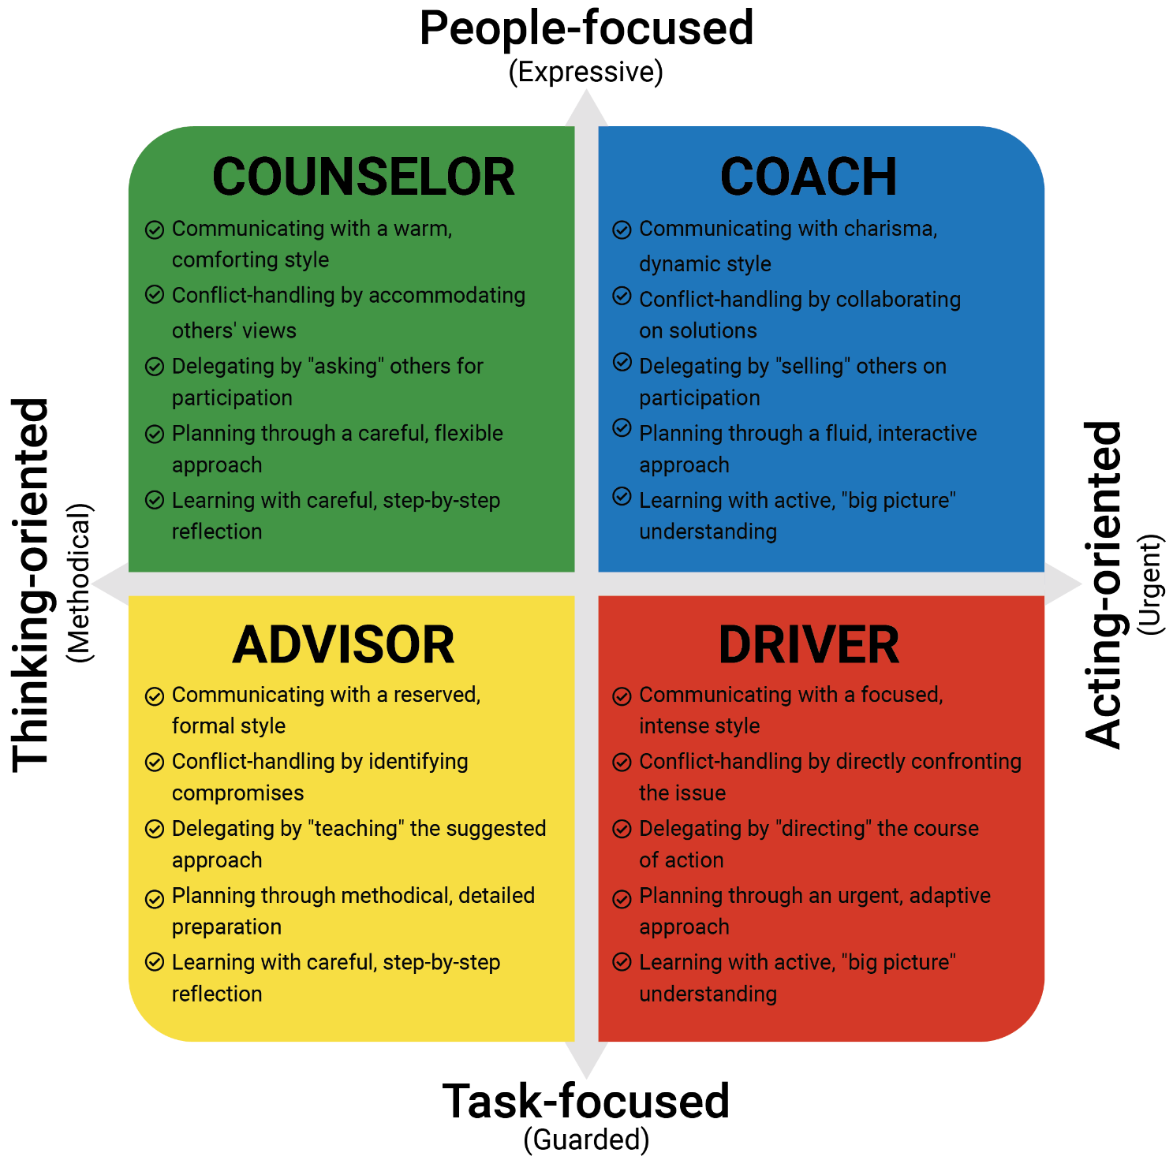
REACH recognises 5 Personal Style Markers for each Personality Style.
- Communicating
- Conflict-Handling
- Delegating
- Planning
- Learning

Activity: Your Personal Markers and Leadership
What have you identified in each of your personal style markers that will either help you to be an effective leader or that you need to improve on to become an effective Leader?
Communicating – My style is Warm & comforting, Charismatic & dynamic, Reserved & formal, Focused & intense (circle one)
Why it helps me | Why it may hinder me

Conflict Handling – My style is Accommodating, Collaborating, Compromising, Directly confronting (circle one)
Why it helps me | Why it may hinder me

Delegating – My style is Asking, Selling, Teaching, Directing (circle one)
Why it helps me | Why it may hinder me

Planning – My style is Careful & flexible, Fluid & interactive, Methodical & detailed, Urgent and adaptive (circle one)
Why it helps me | Why it may hinder me

Learning– My style is Careful step by step reflection; with active big picture understanding (circle one)
Why it helps me | Why it may hinder me

Leading Dimensions
Now that you have reviewed the markers of your style, let’s turn our attention to ten specific dimensions of personality that help to influence how you apply your unique leadership approach. As you influence others, or lead groups and teams, these dimensions interact to shape your most common behavioural patterns. By examining these dimensions in more detail, you can uncover ways in which your behaviours are sources of strength, while also learning where you might benefit from further development. These ten dimensions include five Achieving Dimensions and five Relating Dimensions

Achieving Dimensions
As we have already explored, Achievement Drive describes the way we approach tasks, processes and goals (the “what” of leading). As a motivational source, Achievement Drive can be most evident to us, and those around us, based on five behavioural dimensions. The five Achieving Dimensions include:
1. Accomplishing Goals (a measure of your Work Intensity)
2. Asserting Yourself (a measure of your Assertiveness)
3. Taking Risks (a measure of your Uncertainty Avoidance)
4. Adapting to Change (a measure of your Adaptability)
5. Decision making (a measure of your Perception)

Relating Dimensions
Now that you have explored how your leading style is impacted by the five Achieving Dimensions, let’s shift our attention to the five Relating Dimensions which provide insight regarding how you interact with others and express yourself (the “how” of leading):
1. Competing (a measure of your Status Motivation)
2. Working Together (a measure of your Affiliation)
3. Helping Others (a measure of your Consideration)
4. Opening Up (a measure of your Openness)
5. Protecting Yourself (a measure of your Self-protection)

Activity: Profile Interactions with my team
Reflect on the makeup of your farm workers and their possible profile types and how you might improve communication with your team. In the grid below plot where each of your farm workers could sit. Now for each worker, consider how you should best adapt your leadership and communication style to build better rapport with them, to be able to lead, communicate and influence them more effectively. (Not only take into consideration face to face communication, but also phone and electronic communication)

Coach
Counselor

Driver
Advisor

Recognising your Strengths
The most successful organisations are those that recognise, value and use the strengths of individuals within it and those that value and promote diversity. The following findings have come from research in the last few years (Rock D and Grant H 2016)

What is a Strength?
Psychologist Alex Linley (2008, p9) describes a strength as:
A pre-existing capacity for a particular way of behaving, thinking or feeling, that is authentic and energising to the user, and enables optimal functioning, development and performance
Pioneering work in this area was conducted by Peterson and Seligman (2004) who attempted to classify character strengths and virtues – suggesting that all of us possess these 24 strengths to a certain degree and that they can be scientifically measured. In measuring a person’s strengths, certain strengths will have particularly high scores – these are known as a your ‘signature’ strengths. Seligman argued that if someone recognises their signature strengths and incorporates those into their daily life they will experience authentic happiness.

Activity: My Strengths
Instructions
This questionnaire asks you to identify your strengths. The first two pages describe 24 elements of personality. On the next page you will be asked questions about each of those elements. Be as honest as you can.
Wisdom | 1. Creativity: You are viewed as a creative person; you see, do, and/or create things that are of use; you think of unique ways to solve problems and be productive.
Wisdom | 2. Curiosity: You are an explorer; you seek novelty; you are interested in new activities, ideas, and people; you are open to new experiences.
Wisdom | 3. Judgment/Critical Thinking: You are analytical; you examine things from all sides; you do not jump to conclusions, but instead attempt to weigh all the evidence when making decisions.
Wisdom | 4. Love of Learning: You often find ways to deepen your knowledge and experiences; you regularly look for new opportunities to learn; you are passionate about building knowledge.
Wisdom | 5. Perspective/Wisdom: You take the “big picture” view of things; others turn to you for wise advice; you help others make sense of the world; you learn from your mistakes.
Courage | 6. Bravery/Courage: You face your fears and overcome challenges and adversity; you stand up for what is right; you do not shrink in the face of pain or inner tension or turmoil.
Courage | 7. Perseverance: You keep going and going when you have a goal in mind; you attempt to overcome all obstacles; you finish what you start.
Courage | 8. Honesty: You are a person of high integrity and authenticity; you tell the truth, even when it hurts; you present yourself to others in a sincere way; you take responsibility for your actions.
Courage | 9. Zest: You are enthusiastic toward life; you are highly energetic and activated; you use your energy to the fullest degree.
Humanity | 10. Love: You are warm and genuine to others; you not only share but are open to receiving love from others; you value growing close and intimate with others.
Humanity | 11. Kindness: You do good things for people; you help and care for others; you are generous and giving; you are compassionate.
Humanity | 12. Social Intelligence: You pay close attention to social nuances and the emotions of others; you have good insight into what makes people “tick”; you seem to know what to say and do in any social situation.
Justice | 13. Teamwork: You are a collaborative and participative member on groups and teams; you are loyal to your group; you feel a strong sense of duty to your group; you always do your share.
Justice | 14. Fairness: You believe strongly in an equal and just opportunity for all; you don’t let personal feelings bias your decisions about others; you treat people the way you want to be treated.
Justice | 15. Leadership: You positively influence those you lead; you prefer to lead than to follow; you are very good at organizing and taking charge for the collective benefit of the group.

Temperance | 16. Forgiveness/Mercy: You readily let goof hurt after you are wronged; you give people a second chance; you are not vengeful or resentful; you accept people’s shortcomings.
Temperance | 17. Humility/Modesty: You let your accomplishments speak for themselves; you see your own goodness but prefer to focus the attention on others; you do not see yourself as more special than others; you admit your imperfections.
Temperance | 18. Prudence: You are wisely cautious; you are planful and conscientious; you are careful to not take undue risks or do things you might later regret.
Temperance | 19. Self-Regulation: You are a very disciplined person; you manage your vices and bad habits; you stay calm and cool under pressure; you manage your impulses and emotions.
Transcendence | 20. Appreciation of Beauty & Excellence: You notice the beauty and excellence around you; you are often awe-struck by beauty, greatness, and/or the moral goodness you witness; you are often filled with wonder.
Transcendence | 21. Gratitude: You regularly experience and express thankfulness; you don’t take the good things that happen in your life for granted; you tend to feel blessed in many circumstances.
Transcendence | 22. Hope: You are optimistic, expecting the best to happen; you believe in and work toward a positive future; you can think of many pathways to reach your goals.
Transcendence | 23. Humor: You are playful; you love to make people smile and laugh; your sense of humor helps you connect closely to others; you brighten gloomy situations with fun and/or jokes.
Transcendence | 24. Spirituality/Sense of Meaning: You hold a set of beliefs, whether religious or not, about how your life is part of something bigger and more meaningful; those beliefs shape your behavior and provide a sense of comfort, understanding, and purpose

Instructions
Referencing the descriptions on the previous two pages, place an X in the box in each row that best describes you.
 | Very Strongly Disagree | Strongly Disagree | Disagree | Neutral | Agree | Strongly Agree | Very Strongly Agree
It is natural and effortless for me to express my Creativity strength.
It is natural and effortless for me to express my Curiosity strength.
It is natural and effortless for me to express my Judgment/Critical Thinking strength.
It is natural and effortless for me to express my Love of Learning strength.
It is natural and effortless for me to express my Perspective/Wisdom strength.
It is natural and effortless for me to express my Bravery/Courage strength.
It is natural and effortless for me to express my Perseverance strength.
It is natural and effortless for me to express my Honesty strength.
It is natural and effortless for me to express my Zest strength.
It is natural and effortless for me to express my Love strength.
It is natural and effortless for me to express my Kindness strength.
It is natural and effortless for me to express my Social Intelligence strength.
It is natural and effortless for me to express my Teamwork strength.
It is natural and effortless for me to express my Fairness strength.
It is natural and effortless for me to express my Leadership strength.
It is natural and effortless for me to express my Forgiveness/Mercy strength.
It is natural and effortless for me to express my Humility/Modesty strength.
It is natural and effortless for me to express my Prudence strength.
It is natural and effortless for me to express my Self-Regulation strength.
It is natural and effortless for me to express my Appreciation of Beauty & Excellence strength.
It is natural and effortless for me to express my Gratitude strength.
It is natural and effortless for me to express my Hope strength.
It is natural and effortless for me to express my Humor strength.
It is natural and effortless for me to express my Spirituality/Sense of Meaning.
(Source: Adapted from VIA Institute on Character, www.viacharacter.org, used with permission)
What were your six top strengths? (these are known as your signature strengths)

What strengths would I like to develop as a leader?

Post Session Activities

Action Journal
Your Action Journal is a chronological personal record of your reflections as you move through this course and what actions you will commit to, to improve as a leader. A Journal is another mode of self-reflection and is a vehicle to promote self-awareness and self-improvement.
At the end of each session you will be encouraged to reflect on what was covered and decide what actions you will take to lead more effectively.

The cultural health of my farm
It is important to understand what your workers think about their workplace on-farm – specifically if they work in an environment in which they are effectively supported, inspired, directed and consulted. This goes to the heart of what a workplace culture is.
This activity is asking you to begin conversations on-farm about the culture of the workplace – how your farm workers perceive this and what this means for you and the culture you desire to create.

References
Linley A 2008, Average to A+: Realising strengths in yourself and others, CAPP Press, Coventry
Peterson, C and Seligman, M 2004, Character strengths and virtues: A handbook and classification, American Psychological Association, Washington, DC
Rock D and Grant H 2016, Why diverse teams are smarter, Harvard Business Review, < https://hbr.org/2016/11/why-diverse-teams-are-smarter > viewed February 2018

